Weekly Report
26/10/2026 – 01/11/2026
Group ID: 05
Project Name: Pollaris
Prepared by: Nguyễn Thành Tuân

Team members:
24127579 - Nguyễn Thành Tuân (Project manager, Backend Developer)
24127511 - Trần Hữu Phước (Backend Developer)
24127059 - Dư Bá Khoa (Tester, Frontend Developer)
24127316 - Mạc Văn Hải An (Business Analyst, UI/UX Designer, Frontend Developer)

Achievements since last week:
STT | Description | Due Date | Responsibility | %Complete
1 | [SCRUM-18] Revise Project Plan based on TA feedback (updated schedule, WBS, milestones, highlight changes in blue font) | 01/11/2026 | Nguyễn Thành Tuân | 100%
2 | [SCRUM-18] Detail Use Case 01: Explore and Search Polls (Basic & Alternative Flows, Pre/Post-conditions) | 01/11/2026 | Nguyễn Thành Tuân | 100%
3 | [SCRUM-18] Consolidate Use-case Specs document, cross-check UI consistency, and write Weekly Report | 01/11/2026 | Nguyễn Thành Tuân | 100%
4 | [SCRUM-17] Revise Vision Document (FR/NFR expansion for 6 modules, competitor analysis: StrawPoll, Slido) | 01/11/2026 | Trần Hữu Phước | 100%
5 | [SCRUM-17] Detail Use Case 02: Create a New Poll & Use Case 03: Browse Categories & View AI Recommendations | 01/11/2026 | Trần Hữu Phước | 100%
6 | [SCRUM-16] Detail Use Case 04: Manage Personal Polls & Use Case 05: View and Manage Notifications | 01/11/2026 | Dư Bá Khoa | 100%
7 | [SCRUM-15] Design System Use Case Model (UML diagram on StarUML/draw.io with <<include>> and <<extend>> relationships) | 01/11/2026 | Mạc Văn Hải An | 100%
8 | [SCRUM-15] Detail Use Case 06: Participate in Voting & View Live Results + Review UI Prototypes (Screen 1–6) | 01/11/2026 | Mạc Văn Hải An | 100%

Member Progress Report:
Note on Task Allocation & Progress Tracking:
- Use Case Specifications: Authored collaboratively on Google Docs to avoid binary file merge conflicts; individual contributions and revision timelines are tracked via Google Docs Version History.
- Project Plan & Vision Document: Managed directly in the team's GitHub repository; revisions and feedback updates are tracked through Git commit logs.
- Sprint Management: All tasks are mapped to and updated on our Jira Scrum board.
Link Jira: https://group05-pollaris-24c01.atlassian.net/jira/software/projects/SCRUM/boards/1?filter=&groupBy=none&atlOrigin=eyJpIjoiZGQ4ZWIxMTgwYzA2NDU5MmEyYjA0ODU3YTkxMzIxM2YiLCJwIjoiaiJ9
Link Github: https://github.com/Tuan-01/Pollaris.git
Link Google Docs: https://docs.google.com/document/d/1vBEiXnaUHCp3m05vhFE1tevfwFD7eElkwJP1Sr7Mum0/edit?usp=sharing
Nguyễn Thành Tuân – 24127579:
- Done Task: [PA2] Revised Project Plan + Write Use Case 1: Explore and Search Polls + Write Weekly Report + Update Use Case document
- Assignee: Nguyễn Thành Tuân
- Created Date: Oct 17, 2026
- Due Date: Oct 31, 2026
- Last Update Date: Oct 31, 2026
- Jira Screenshot:
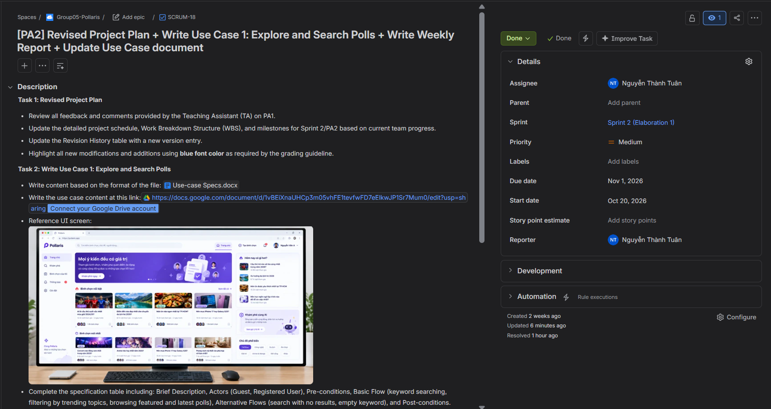

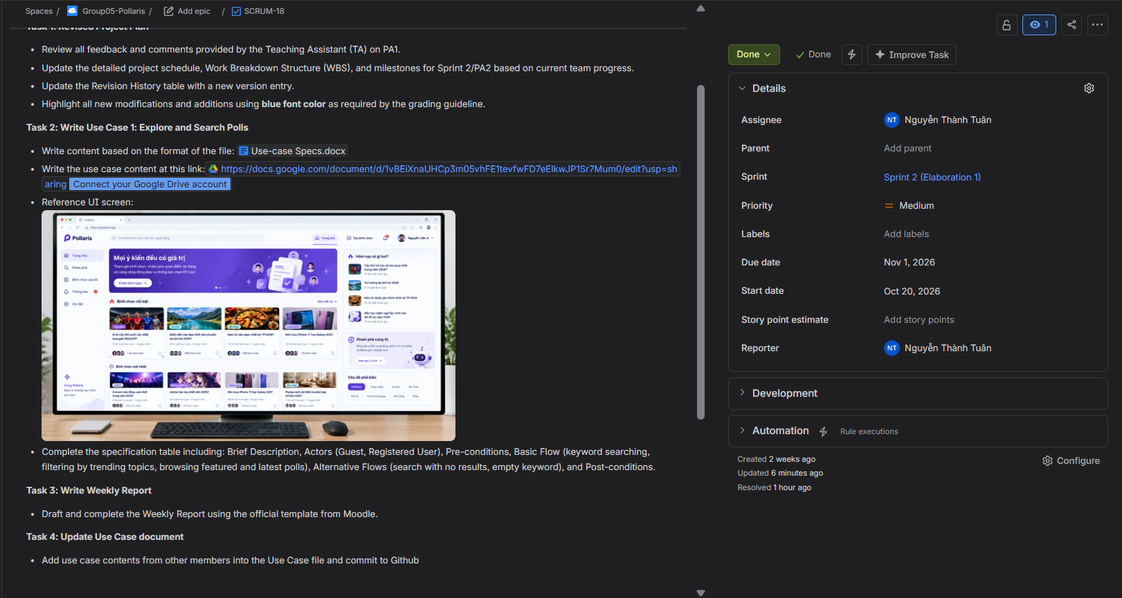

Google Docs Track:
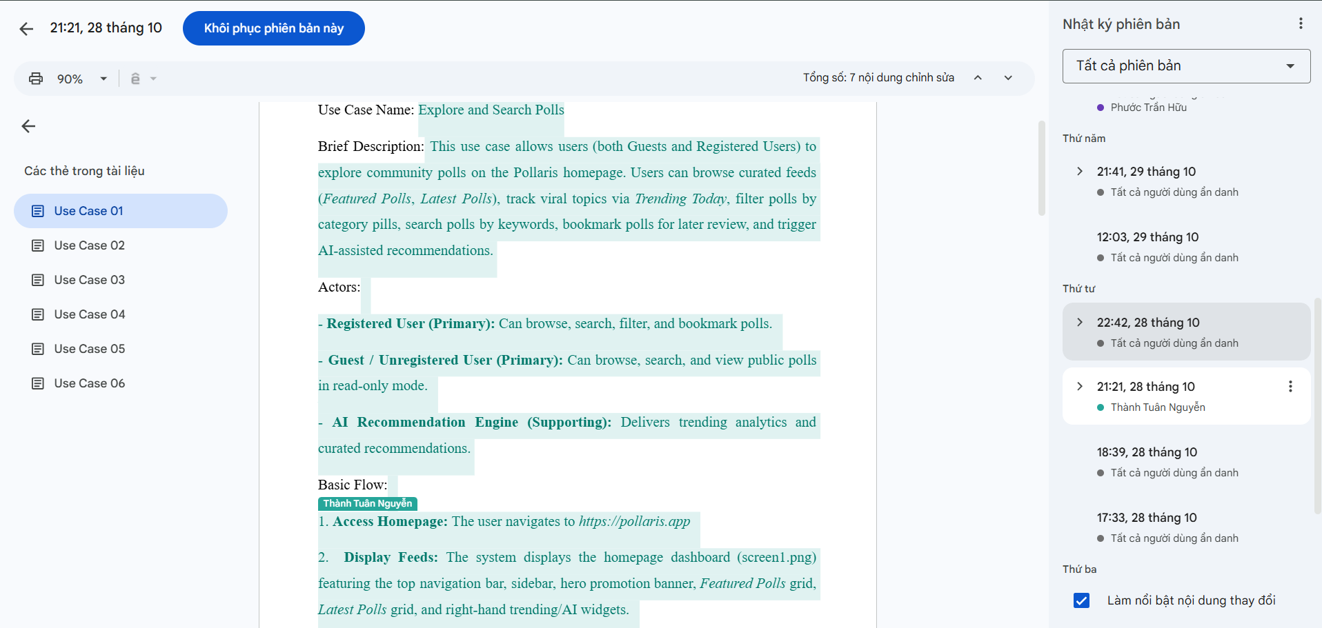
Github Commit Log:
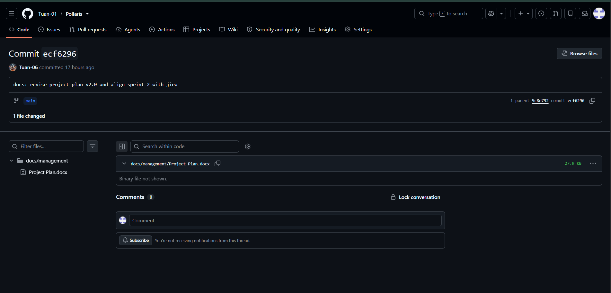
Trần Hữu Phước – 24127511:
- Done Task: [PA2] Revised Vision Document + Write Use Case 2: Create a New Poll + Write Use Case 3: Browse Categories & View AI Recommendations
- Assignee: Trần Hữu Phước
- Created Date: Oct 17, 2026
- Due Date: Oct 31, 2026
- Last Update Date: Oct 31, 2026
- Jira Screenshot:
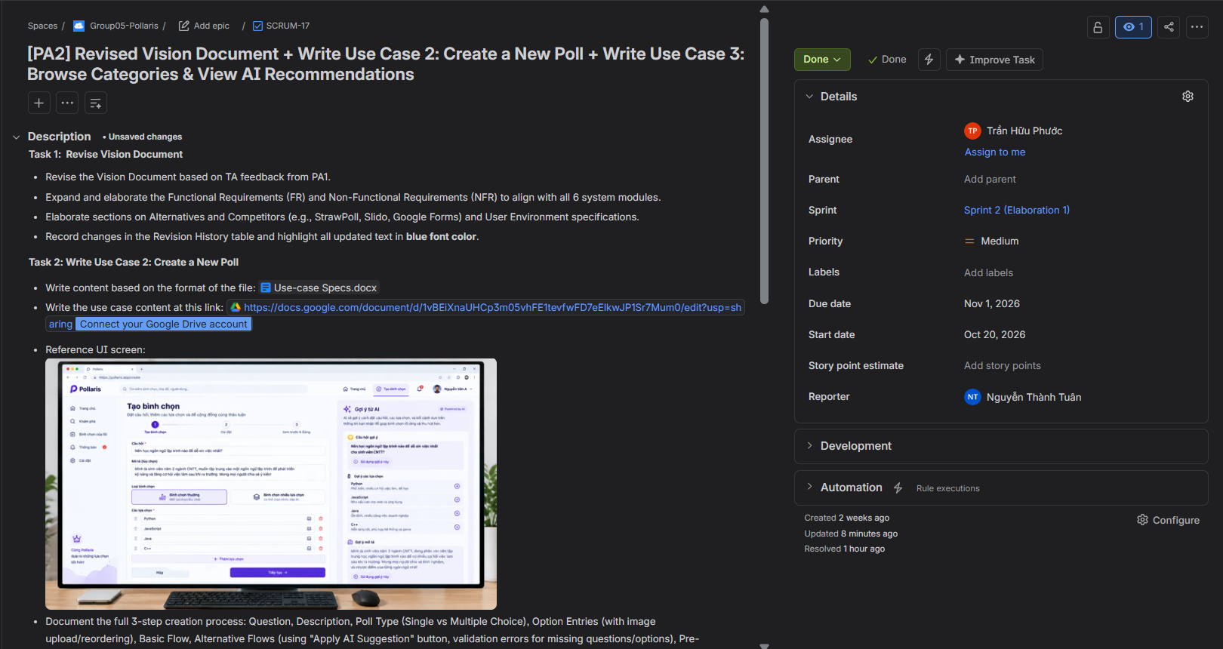

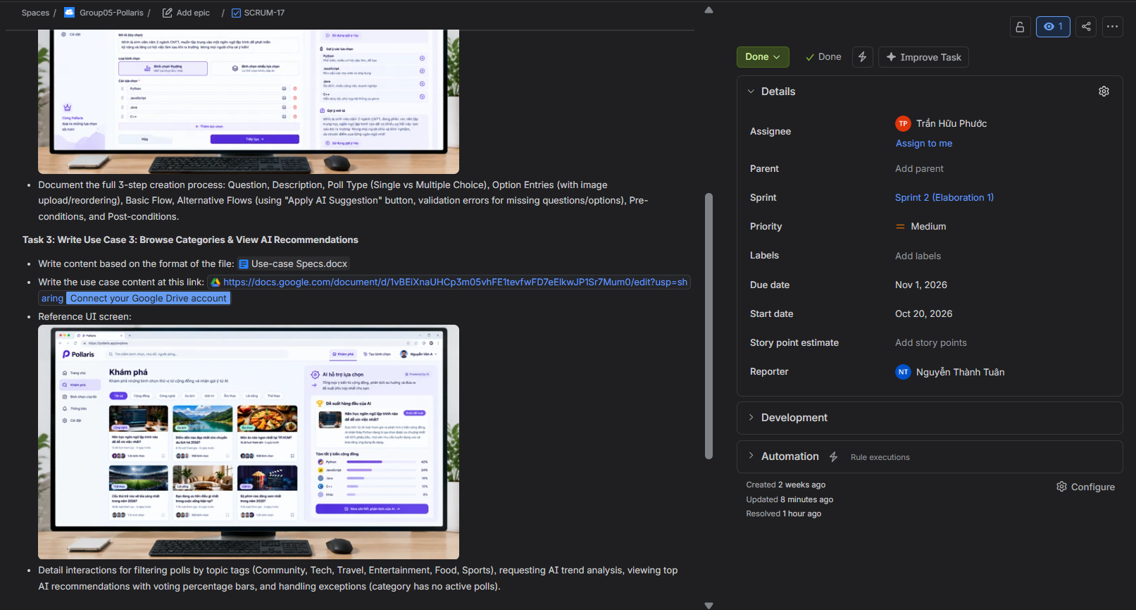

Google Docs Track:
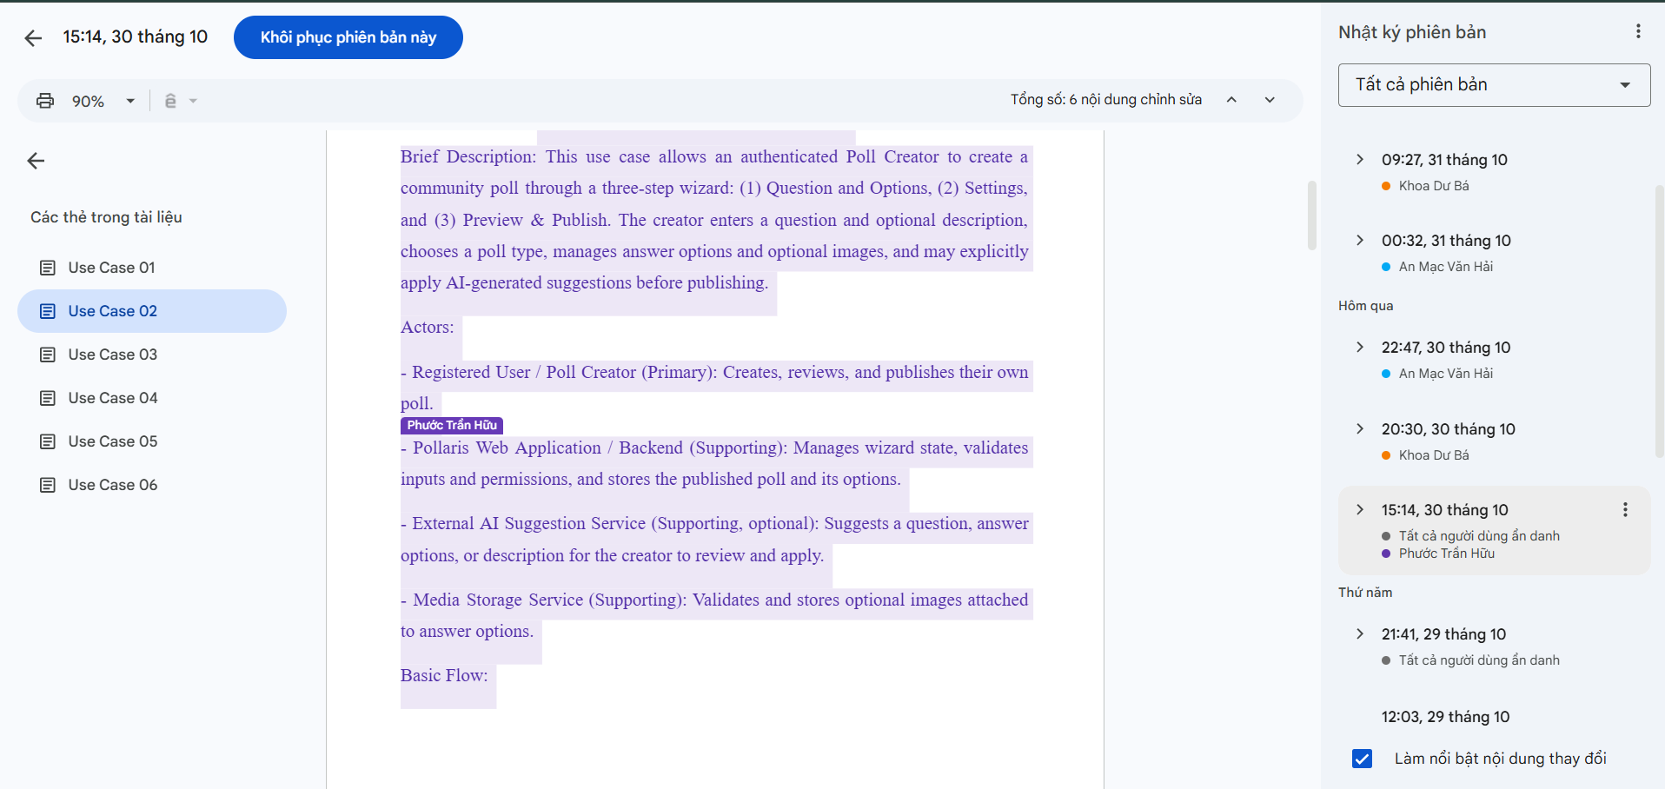

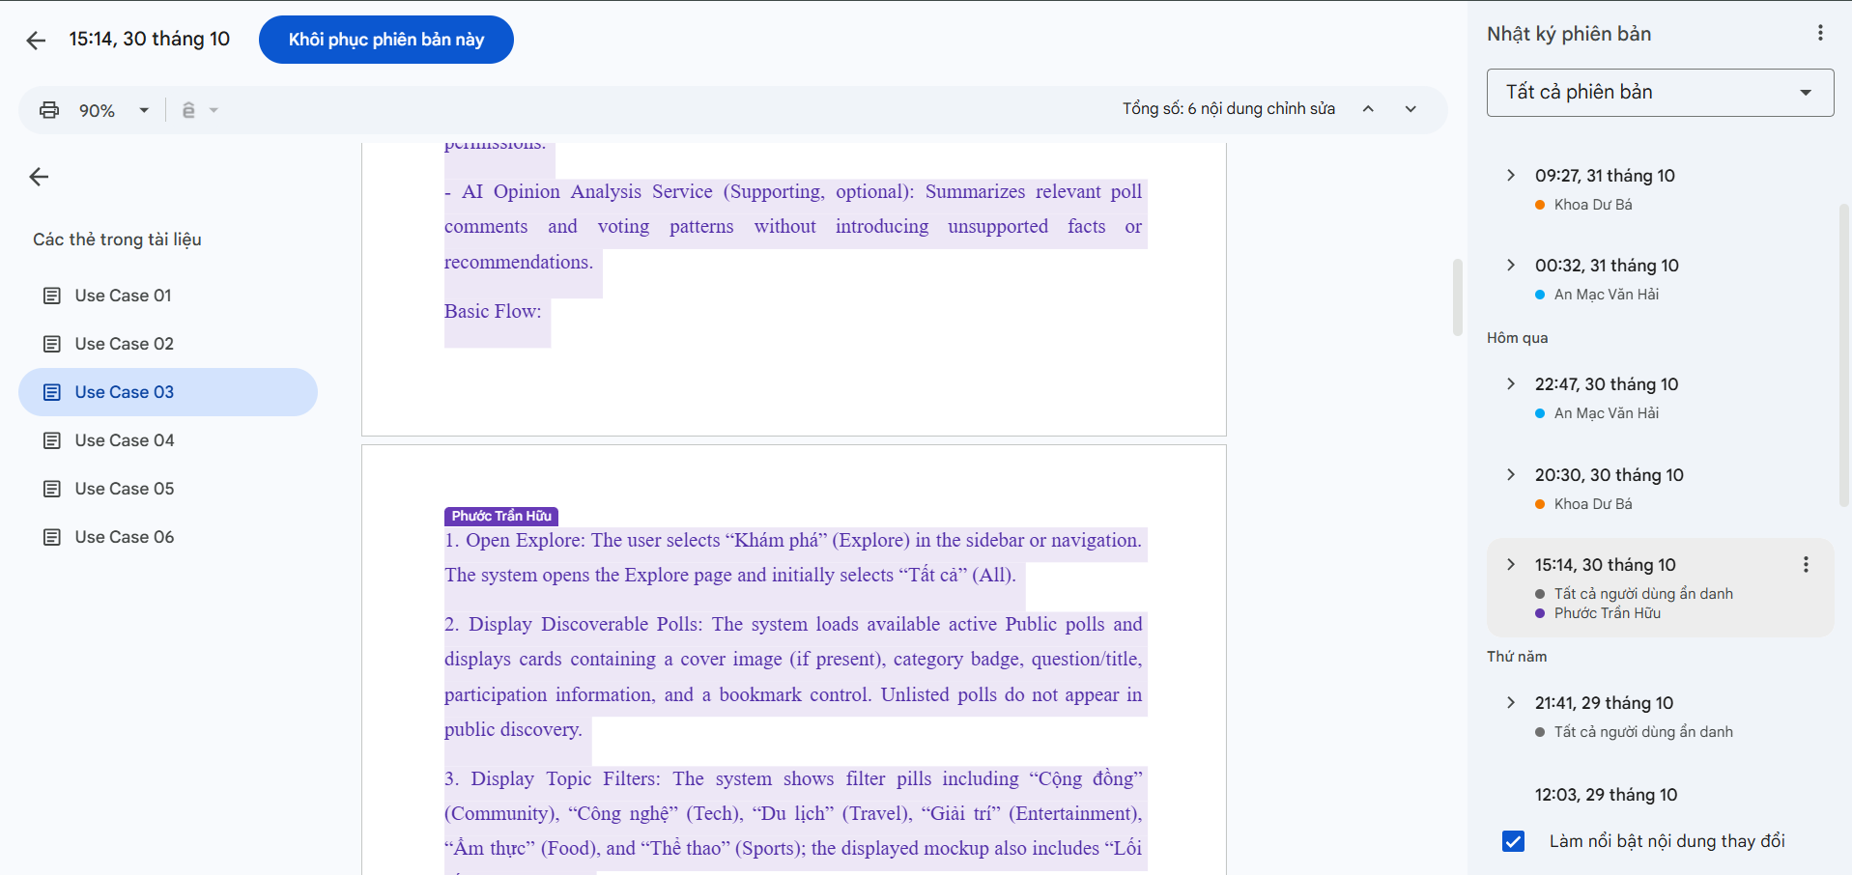
Github Commit Log:
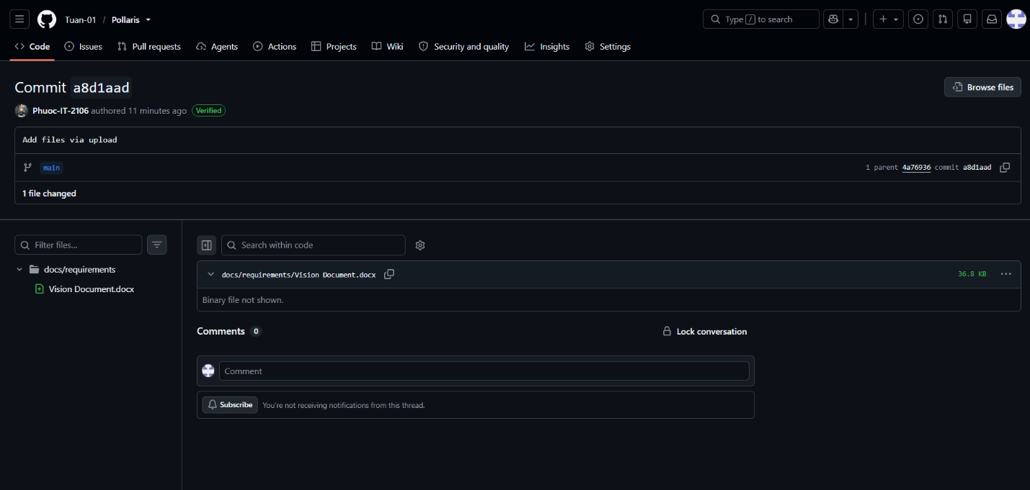
Mạc Văn Hải An – 24127316:
- Done Task: [PA2] Design Use Case Model + Write Use Case 6: Participate in Voting & View Live Results + Review UI Prototypes
- Assignee: Mạc Văn Hải An
- Created Date: Oct 17, 2026
- Due Date: Oct 31, 2026
- Last Update Date: Oct 31, 2026
- Jira Screenshot:
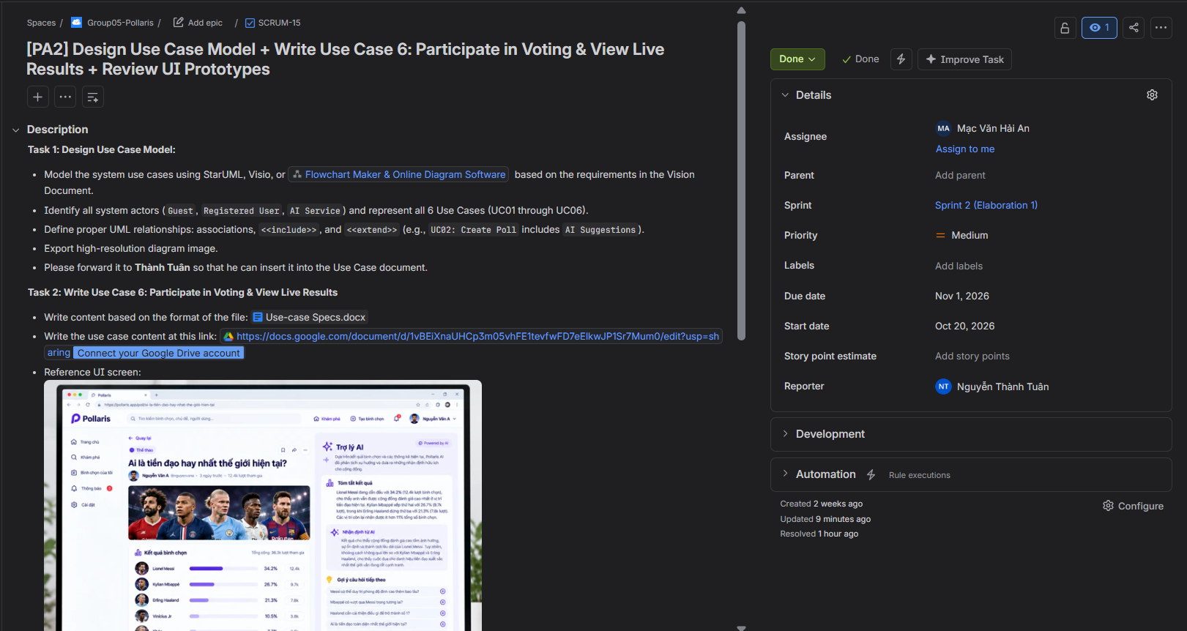

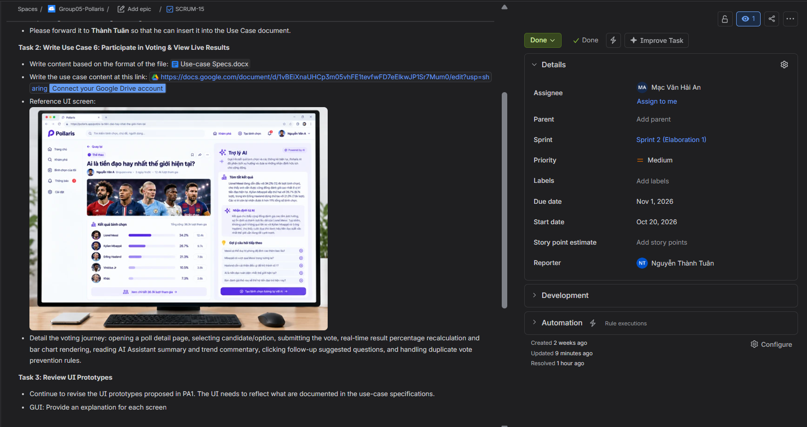

Google Docs Track:
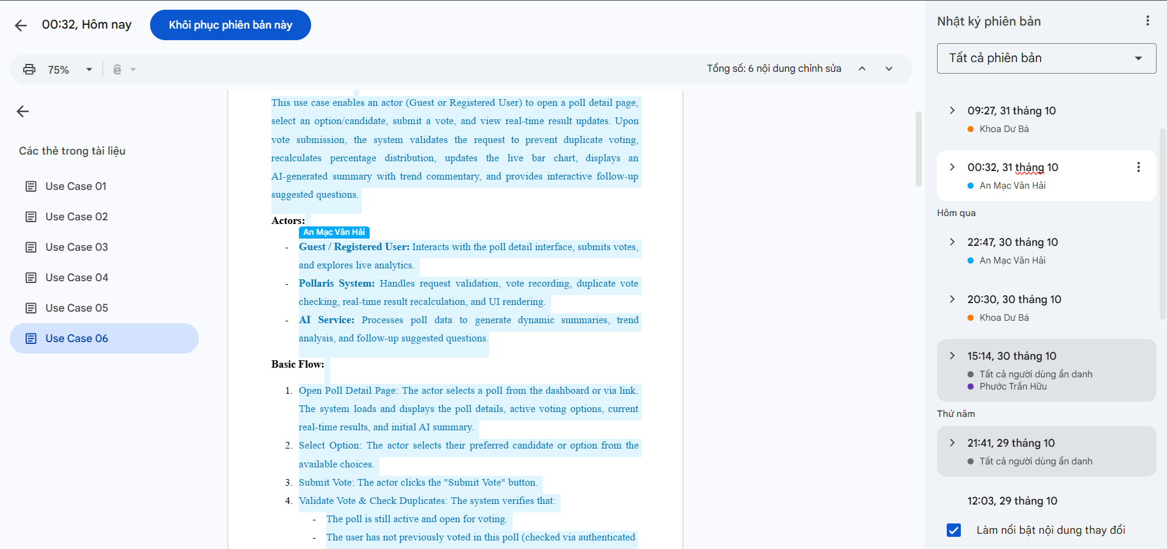
Github Commit Log:
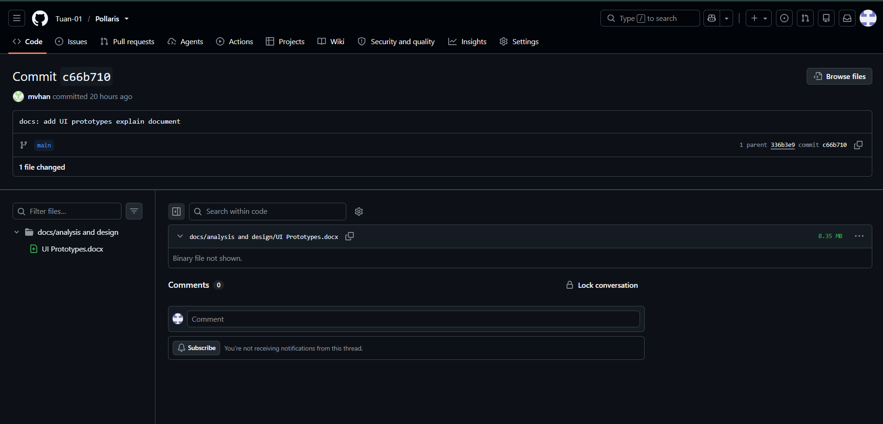
Dư Bá Khoa – 24127059:
- Done Task: [PA2] Write Use Case 4: Manage Personal Polls & Use Case 5: View and Manage Notifications
- Assignee: Dư Bá Khoa
- Created Date: Oct 17, 2026
- Due Date: Oct 31, 2026
- Last Update Date: Oct 31, 2026
- Jira Screenshot:
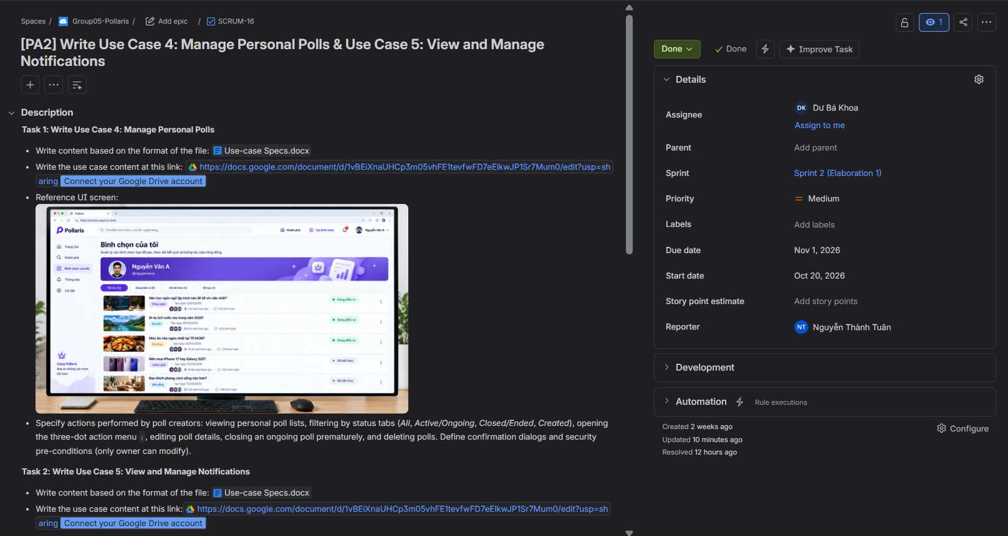

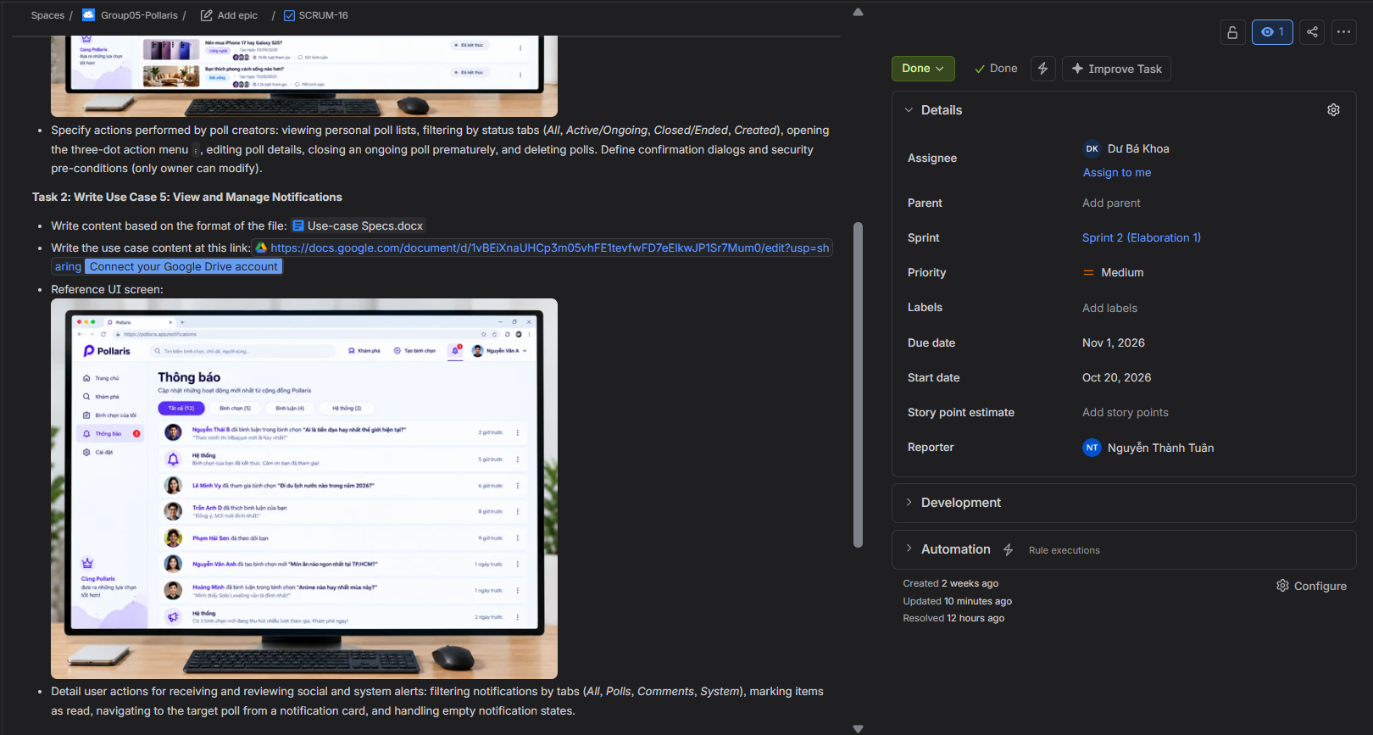
Google Docs Track:
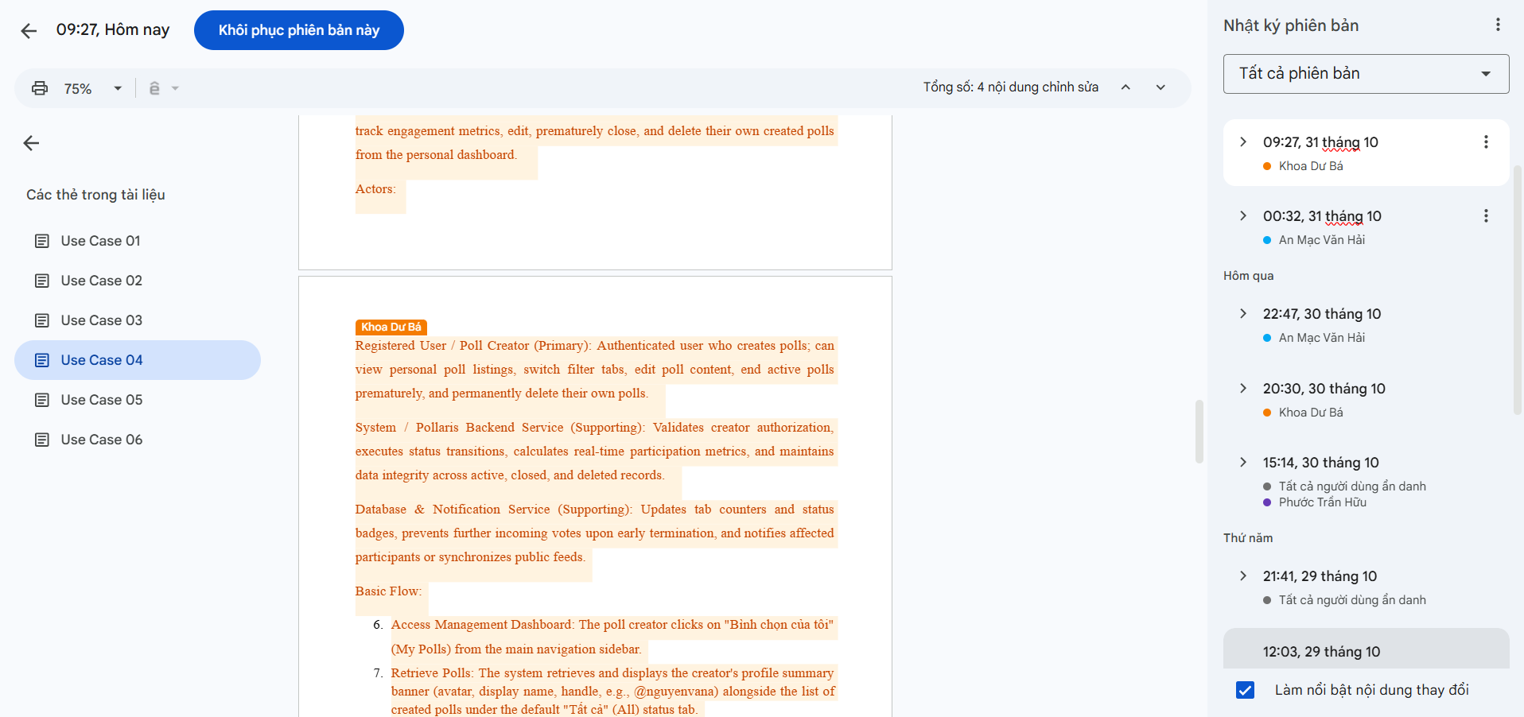
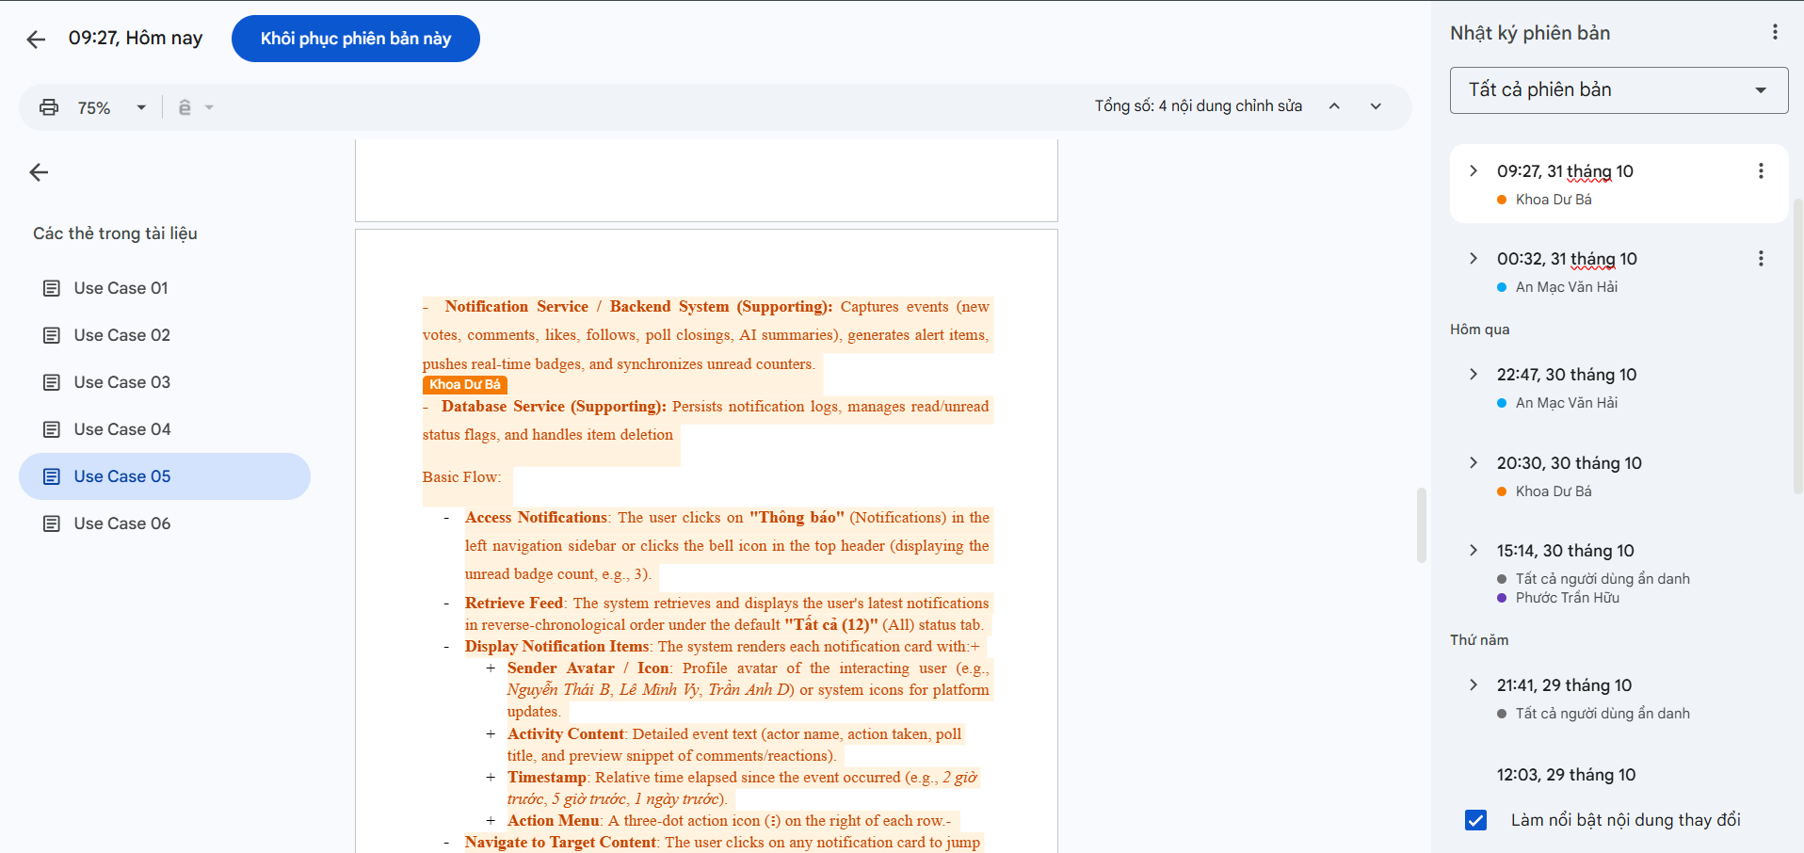

Issues and impacts:
- Unfamiliarity with Jira-based Task Management:
- Issue: The team was new to using Jira for agile tracking, particularly when it came to breaking deliverables down into structured tickets and updating card statuses on a daily basis.
- Impact: Progress tracking on the board initially lagged behind actual work, requiring additional effort to sync ticket statuses and worklogs before writing the report.
- Inexperience with UML Use Case Modeling:
- Issue: Members had limited hands-on experience in formal UML modeling, especially in distinguishing system boundaries and correctly applying <<include>> versus <<extend>> relationships.
- Impact: Designing the Use Case Diagram took multiple rounds of internal discussion and rework, which slightly delayed the final diagram export.
- Difficulties in Forward Planning for the Next Sprint:
- Issue: The team is accustomed to reactive planning—waiting for explicit assignment instructions or rubrics before delegating work—making proactive sprint forecasting unfamiliar and challenging.
- Impact: Structuring the backlog and estimating workloads for Sprint 3 (PA3) required a lot of guesswork and took longer than expected to define.

- Tendency to Push Work Close to the Deadline:
- Issue: Work was not distributed evenly throughout the sprint window; tasks were mostly picked up and completed in the final few days before the due date.
- Impact: This created a heavy workload compression toward the end of the sprint, leaving little buffer time for thorough cross-review and document compilation.
- Inadequate Review of Use Case Model Requirements:
- Issue: The team did not read the assignment prompt carefully before starting, initially missing specific instructions regarding the Use Case Model—such as properly identifying all system actors (including the external AI Service) and placing the diagram directly inside the Use-case Specification document.
- Impact: We had to redraw parts of the diagram and reorganize the document layout late in the sprint, resulting in unnecessary rework and putting extra time pressure on the final submission.

Next week's goals:
STT | Description | Due Date | Responsibility
1 | [POL-28] Implement Authentication & Session Management Backend (User registration, login, JWT verification, bcrypt password hashing, and profile API) | 15/11/2026 | Nguyễn Thành Tuân
2 | [POL-31] Build 1 Integration Testing & Defect Tracking (Integrate core modules, execute test suite against Build 1, verify database constraints, and log issues) | 15/11/2026 | Nguyễn Thành Tuân
3 | [POL-32] Compile Weekly Reports 5 & 6 and track Sprint 3 progress on Jira | 15/11/2026 | Mạc Văn Hải An
4 | [POL-25] Design Database Schema & Data Models (PostgreSQL relational schema, foreign key constraints, indexes, and Prisma migration scripts) | 15/11/2026 | Trần Hữu Phước
5 | [POL-30] Implement Core Voting Engine & Atomic Tally API (Atomic vote casting endpoint, concurrency control, duplicate vote prevention, and real-time count tally update) | 15/11/2026 | Trần Hữu Phước
6 | [POL-29] Implement Poll Creation & Option Authoring Frontend (Poll creation form, input validation, dynamic option list, and category selector UI components) | 15/11/2026 | Dư Bá Khoa
7 | [POL-26] UML Detailed Design (Design UML Class Diagrams for poll/vote models and Sequence Diagrams for voting and summarization workflows) | 15/11/2026 | Dư Bá Khoa
8 | [POL-27] Author Test Plan & Automated Test Specs (Define test matrix, write unit and integration test cases for Authentication, Poll Creation, and Voting Engine) | 15/11/2026 | Mạc Văn Hải An

Nguyễn Thành Tuân – 24127579:
- Todo Task 1: [PA3] Authentication & Session Management Backend
- Assignee: Nguyễn Thành Tuân
- Created Date: Oct 31, 2026
- Due Date: Nov 15, 2026
- Last Update Date: Oct 31, 2026
- Jira Screenshot:
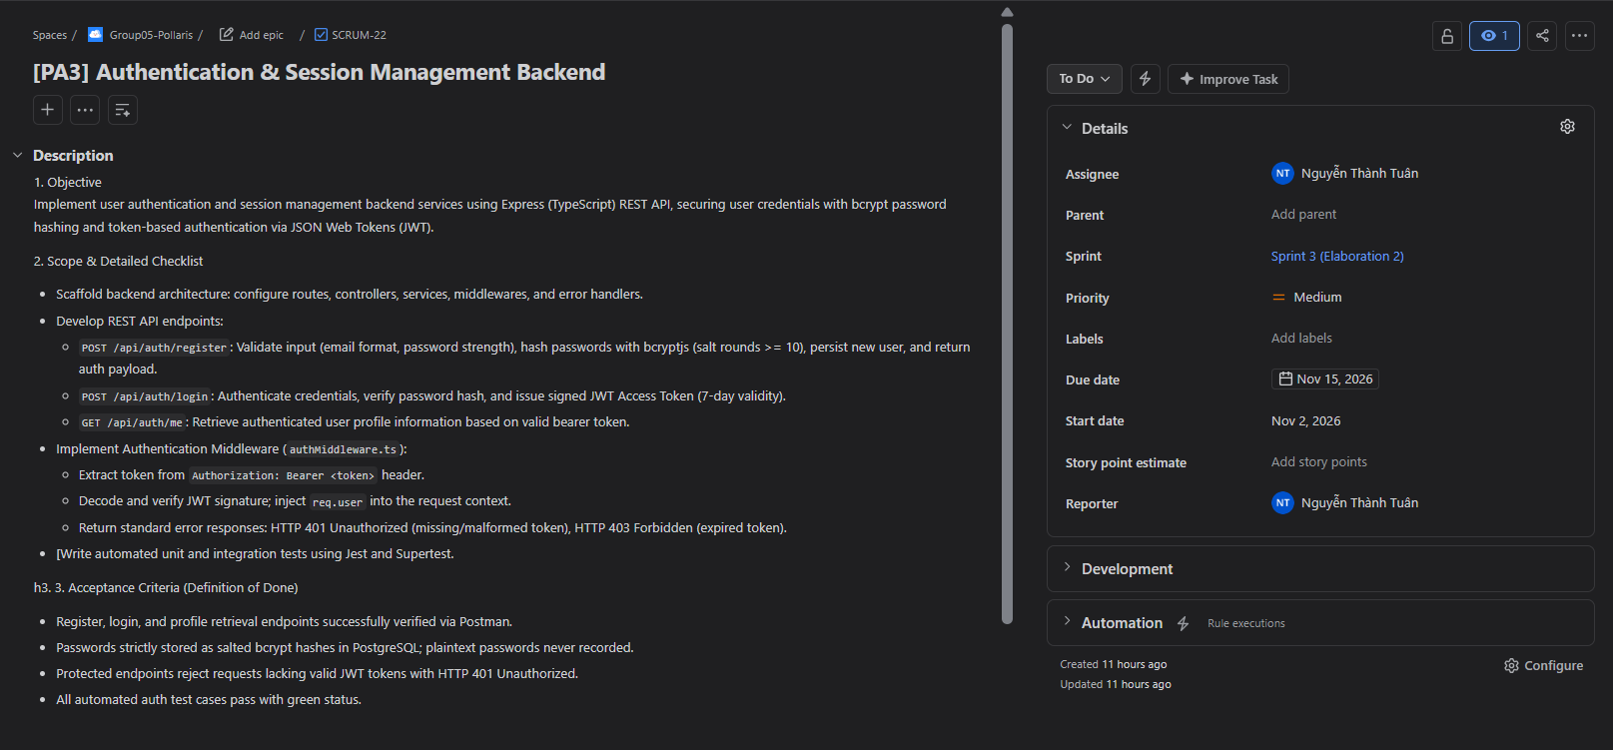
- Todo Task 2: [PA3] Build 1 Integration Testing & Defect Tracking
- Assignee: Nguyễn Thành Tuân
- Created Date: Oct 31, 2026
- Due Date: Nov 15, 2026
- Last Update Date: Oct 31, 2026
- Jira Screenshot:
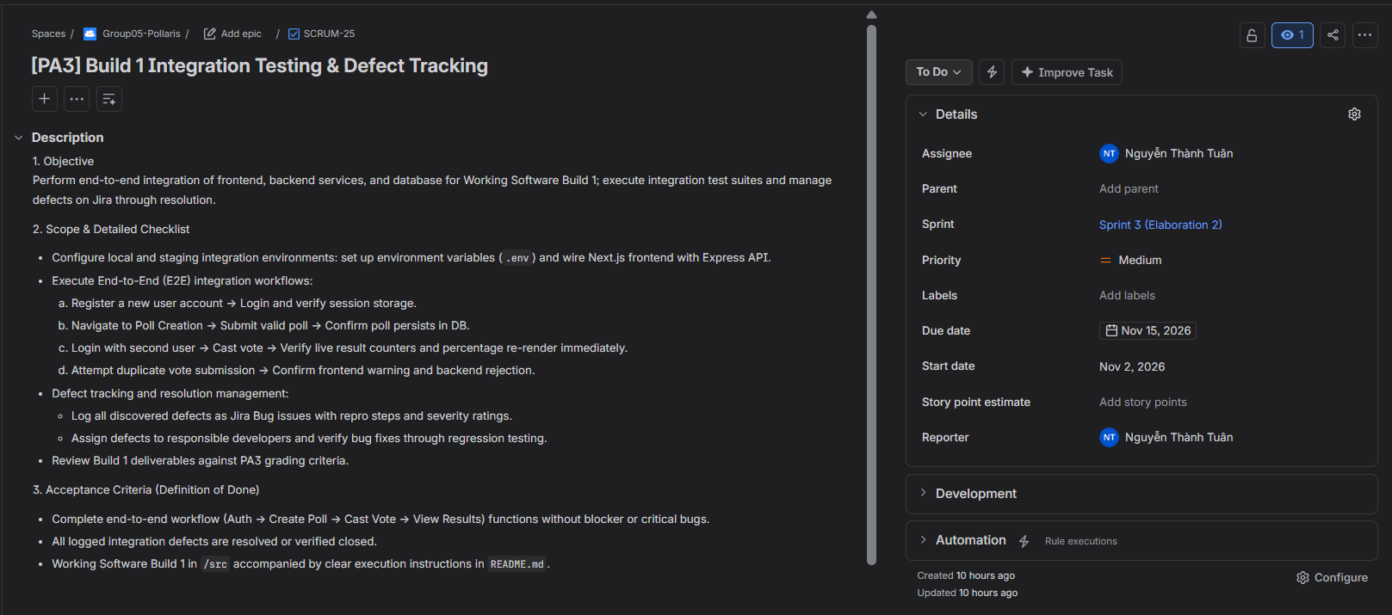

Trần Hữu Phước – 24127511:
- Todo Task 1: [PA3] Database Schema & Data Models
- Assignee: Trần Hữu Phước
- Created Date: Oct 31, 2026
- Due Date: Nov 15, 2026
- Last Update Date: Oct 31, 2026
- Jira Screenshot:
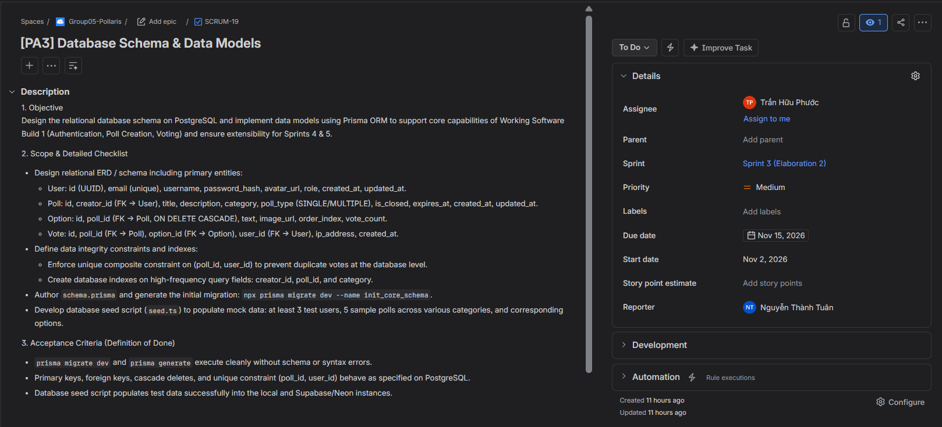
- Todo Task 2: [PA3] Core Voting Engine & Atomic Tally API
- Assignee: Trần Hữu Phước
- Created Date: Oct 31, 2026
- Due Date: Nov 15, 2026
- Last Update Date: Oct 31, 2026
- Jira Screenshot:
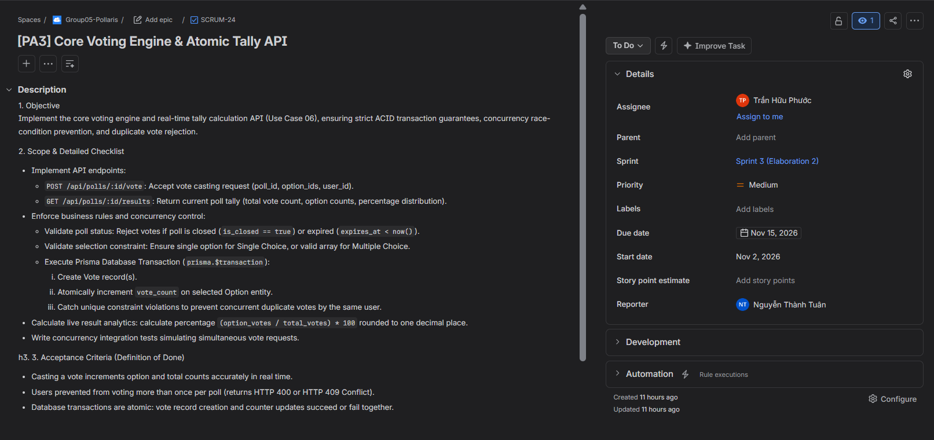
Mạc Văn Hải An – 24127316:
- Todo Task 1: [PA3] Test Plan Authoring & Automated Test Specs
- Assignee: Mạc Văn Hải An
- Created Date: Oct 31, 2026
- Due Date: Nov 15, 2026
- Last Update Date: Oct 31, 2026
- Jira Screenshot:
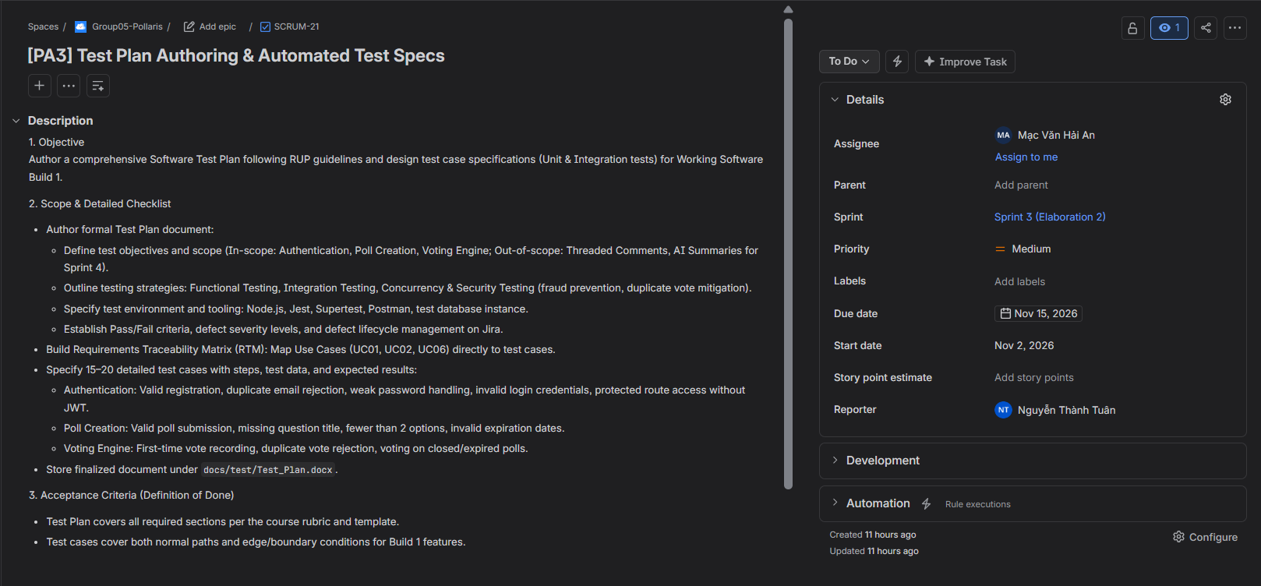
- Todo Task 2: [PA3] Weekly Reports 5 & 6 Compilation
- Assignee: Mạc Văn Hải An
- Created Date: Oct 31, 2026
- Due Date: Nov 15, 2026
- Last Update Date: Oct 31, 2026
- Jira Screenshot:
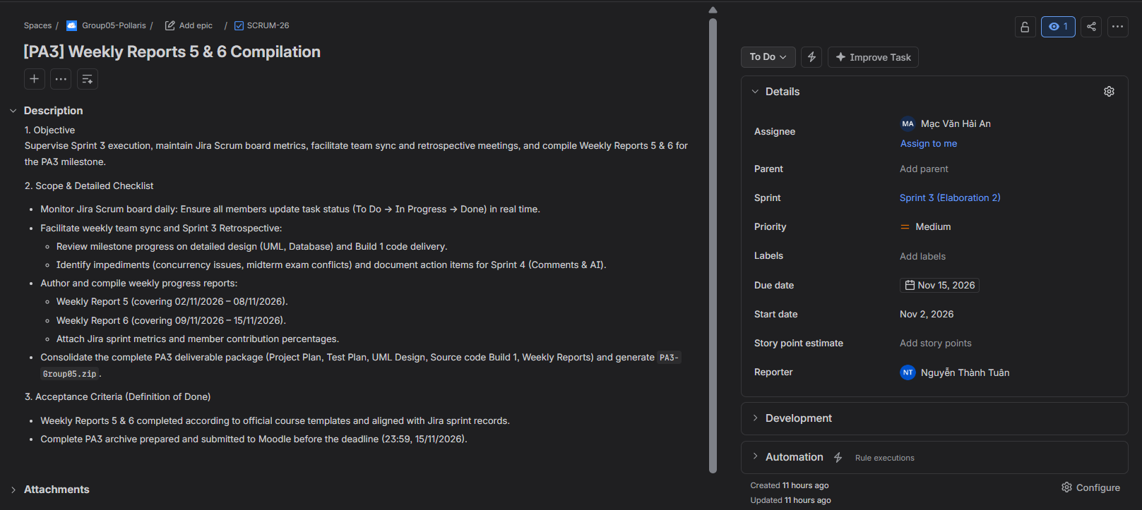
Dư Bá Khoa – 24127059:
- Todo Task 1: [PA3] UML Detailed Design (Class & Sequence Diagrams)
- Assignee: Dư Bá Khoa
- Created Date: Oct 31, 2026
- Due Date: Nov 15, 2026
- Last Update Date: Oct 31, 2026
- Jira Screenshot:
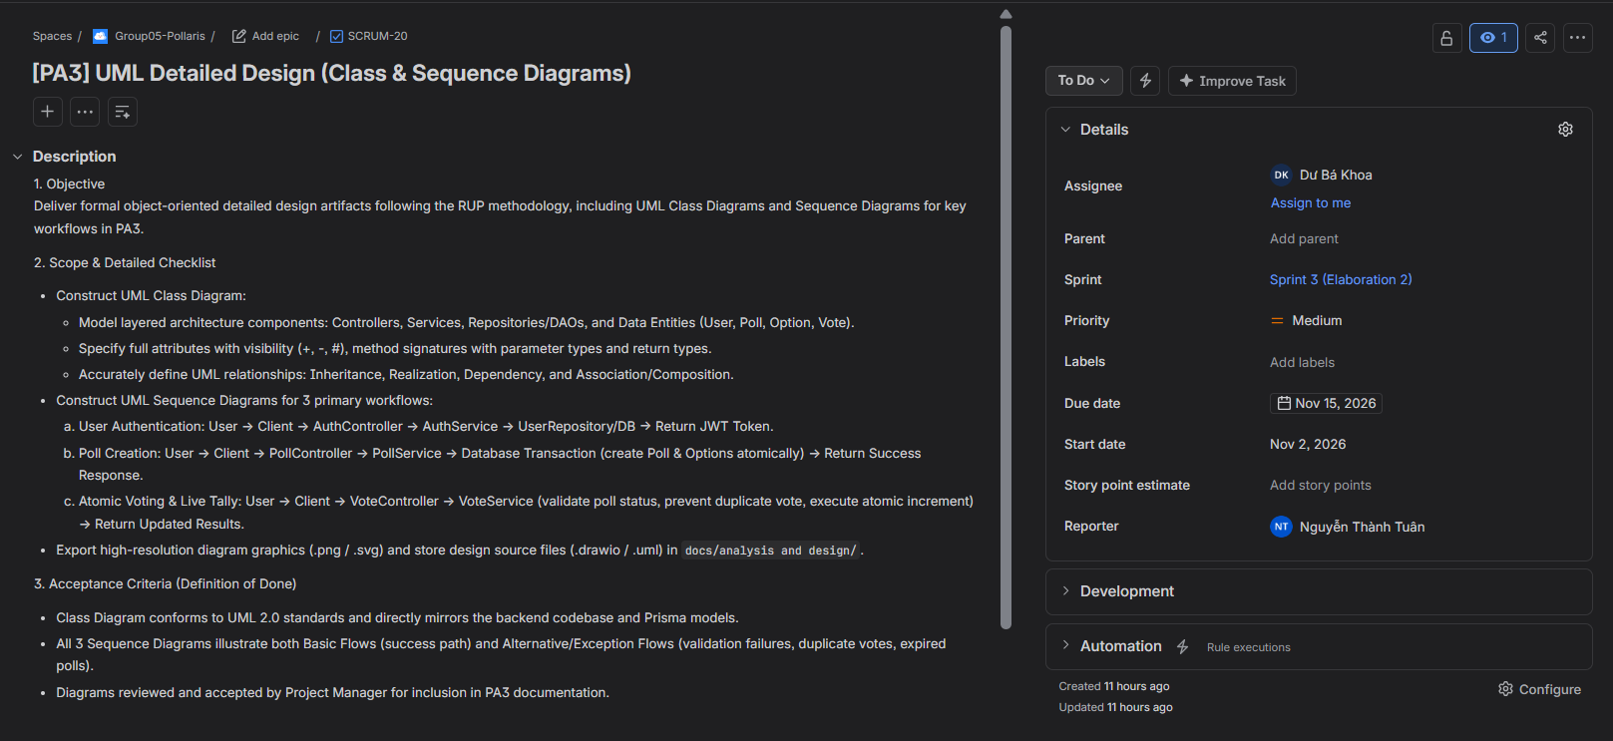
- Todo Task 2: [PA3] Poll Creation & Option Authoring Frontend
- Assignee: Dư Bá Khoa
- Created Date: Oct 31, 2026
- Due Date: Nov 15, 2026
- Last Update Date: Oct 31, 2026
- Jira Screenshot:


